Hasil Tes Remote

Dpad Values:
Left: 0x08
Down: 0x02
Right: 0x04
Up: 0x01

Button Values
Triangle: 0x0008
Circle: 0x0002
Cross: 0x0001
Square: 0x0004
L3: 0x0100
R3: 0x0200

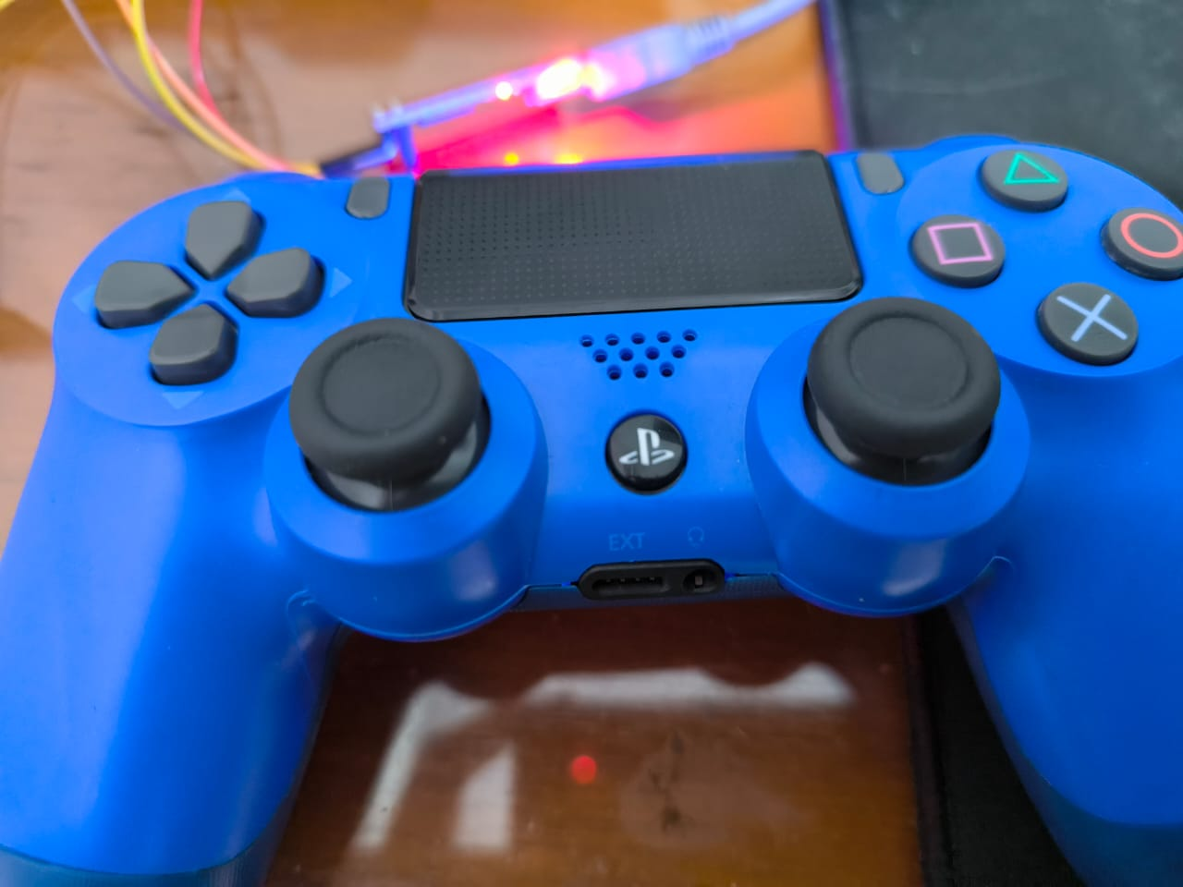
What does above image mean?
X-Axis range: -508 – 512 (left to right)
Y-Axis range: -508 – 512 (up to down)
If the L or R axis is steered diagonally, it will combine both X and Y axis values, creating cartesian coordinate-like result.

What about if there are 2 buttons pressed at the same time?
Simply add both values together. Example: Pressing Dpad Left and Down will result in 0x0A, which is the result of 0x08 (left) + 0x02 (right).

Additional Notes:
The properties for controller have more than 15 attributes, 4 of which are the dpad, buttons, L axis, and R axis. There are others like throttle, gyro, x, y, z, accel, etc. Right now, idk how to use them yet.

Code (In Progress)
#include <Bluepad32.h>

ControllerPtr myControllers[BP32_MAX_GAMEPADS];

void onConnectedController(ControllerPtr ctl) {
bool foundEmptySlot = false;
for (int i = 0; i < BP32_MAX_GAMEPADS; i++) {
if (myControllers[i] == nullptr) {
Serial.printf("CALLBACK: Controller is connected, index=%d\n", i);
// Additionally, you can get certain gamepad properties like:
// Model, VID, PID, BTAddr, flags, etc.
ControllerProperties properties = ctl->getProperties();
Serial.printf("Controller model: %s, VID=0x%04x, PID=0x%04x\n", ctl->getModelName().c_str(), properties.vendor_id,
properties.product_id);
myControllers[i] = ctl;
foundEmptySlot = true;
break;
}
}
if (!foundEmptySlot) {
Serial.println("CALLBACK: Controller connected, but could not found empty slot");
}
}

void onDisconnectedController(ControllerPtr ctl) {
bool foundController = false;

for (int i = 0; i < BP32_MAX_GAMEPADS; i++) {
if (myControllers[i] == ctl) {
Serial.printf("CALLBACK: Controller disconnected from index=%d\n", i);
myControllers[i] = nullptr;
foundController = true;
break;
}
}

if (!foundController) {
Serial.println("CALLBACK: Controller disconnected, but not found in myControllers");
}
}

void dumpGamepad(ControllerPtr ctl) {
Serial.printf(
"idx=%d, dpad: 0x%02x, buttons: 0x%04x, axis L: %4d, %4d, axis R: %4d, %4d, brake: %4d, throttle: %4d, "
"misc: 0x%02x, gyro x:%6d y:%6d z:%6d, accel x:%6d y:%6d z:%6d\n",
ctl->index(), // Controller Index
ctl->dpad(), // D-pad
ctl->buttons(), // bitmask of pressed buttons
ctl->axisX(), // (-511 - 512) left X Axis
ctl->axisY(), // (-511 - 512) left Y axis
ctl->axisRX(), // (-511 - 512) right X axis
ctl->axisRY(), // (-511 - 512) right Y axis
ctl->brake(), // (0 - 1023): brake button
ctl->throttle(), // (0 - 1023): throttle (AKA gas) button
ctl->miscButtons(), // bitmask of pressed "misc" buttons
ctl->gyroX(), // Gyro X
ctl->gyroY(), // Gyro Y
ctl->gyroZ(), // Gyro Z
ctl->accelX(), // Accelerometer X
ctl->accelY(), // Accelerometer Y
ctl->accelZ() // Accelerometer Z
);
}

void processGamepad(ControllerPtr ctl) {
// There are different ways to query whether a button is pressed.
// By query each button individually:
// a(), b(), x(), y(), l1(), etc...
if (ctl->a()) {
static int colorIdx = 0;
// Some gamepads like DS4 and DualSense support changing the color LED.
// It is possible to change it by calling:
switch (colorIdx % 3) {
case 0:
// Red
ctl->setColorLED(255, 0, 0);
break;
case 1:
// Green
ctl->setColorLED(0, 255, 0);
break;
case 2:
// Blue
ctl->setColorLED(0, 0, 255);
break;
}
colorIdx++;
}

if (ctl->b()) {
// Turn on the 4 LED. Each bit represents one LED.
static int led = 0;
led++;
ctl->setPlayerLEDs(led & 0x0f);
}

if (ctl->x()) {
ctl->playDualRumble(0 /* delayedStartMs */, 250 /* durationMs */, 0x80 /* weakMagnitude */,
0x40 /* strongMagnitude */);
}

// Another way to query controller data is by getting the buttons() function.
// See how the different "dump*" functions dump the Controller info.

if (ctl->dpad() == 0x08) { // Left D-pad
Serial.println("D-pad Left pressed");
}
else if (ctl->dpad() == 0x02) { // Down D-pad
Serial.println("D-pad Down pressed");
}
else if (ctl->dpad() == 0x04) { // Right D-pad
Serial.println("D-pad Right pressed");
}
else if (ctl->dpad() == 0x01) { // Up D-pad
Serial.println("D-pad Up pressed");
}

if (ctl->dpad() == (0x08 | 0x02)) { // Left + Down (0x08 + 0x02 = 0x0A)
Serial.println("D-pad Left + Down pressed");
}
else if (ctl->dpad() == (0x08 | 0x04)) { // Left + Right (0x08 + 0x04 = 0x0C)
Serial.println("D-pad Left + Right pressed");
}
else if (ctl->dpad() == (0x02 | 0x04)) { // Down + Right (0x02 + 0x04 = 0x06)
Serial.println("D-pad Down + Right pressed");
}
else if (ctl->dpad() == (0x01 | 0x08)) { // Up + Left (0x01 + 0x08 = 0x09)
Serial.println("D-pad Up + Left pressed");
}
else if (ctl->dpad() == (0x01 | 0x02)) { // Up + Down (0x01 + 0x02 = 0x03)
Serial.println("D-pad Up + Down pressed");
}
else if (ctl->dpad() == (0x01 | 0x04)) { // Up + Right (0x01 + 0x04 = 0x05)
Serial.println("D-pad Up + Right pressed");
}
// Check for all directions pressed together (0x08 + 0x02 + 0x04 + 0x01 = 0x0F)
else if (ctl->dpad() == (0x08 | 0x02 | 0x04 | 0x01)) { // All directions
Serial.println("All D-pad directions pressed");
}
dumpGamepad(ctl);
}

void processControllers() {
for (auto myController : myControllers) {
if (myController && myController->isConnected() && myController->hasData()) {
processGamepad(myController);
}
}
}

// Arduino setup function. Runs in CPU 1
void setup() {
Serial.begin(115200);
Serial.printf("Firmware: %s\n", BP32.firmwareVersion());
const uint8_t* addr = BP32.localBdAddress();
Serial.printf("BD Addr: %2X:%2X:%2X:%2X:%2X:%2X\n", addr[0], addr[1], addr[2], addr[3], addr[4], addr[5]);

// Setup the Bluepad32 callbacks
BP32.setup(&onConnectedController, &onDisconnectedController);

BP32.forgetBluetoothKeys();
BP32.enableVirtualDevice(false);
}

void loop() {

bool dataUpdated = BP32.update();
if (dataUpdated)
processControllers();

delay(150);
}

